**Exercise-10**

**Question-1:-**

**Output:-**

Here we observe that the patient details are sorted in descending order and sorted by age and we observe that a particular p-id is present in the list or not

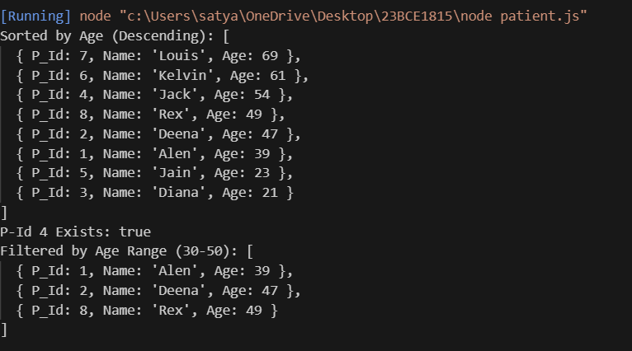

**Question-2:-**

**Output:-**

Here we observe that different DOM selection methods we observed getElementById,getElementsByName,getElementsByTagName,getElementsByClassName,querySelector,querySelectorAll

**Question-3:-**

**Output:-**

Here we observed grocery order form

By clicking on submit another page will open there we observe order receipt

